Choice Form for Open Elective at Institute Level. (B. Tech VII Semester AY 2020-21)
Name of the Student | Shreyansh Chheda
Roll No | 171070025 | Discipline | Computer Engineering
SPI of 5thSemester | 7.46 | CPI till 5thSemester | 7.66
Contact No (mobile) | 9820477990 | Email I.D. | shreyansh.chheda@gmail.com

Sr No | Course Title | Department  Offering Elective Course | Following Discipline  Students are not Eligible for respective elective | Preference No
1 | Basic Laws of ElectricalEngineering | Electrical | Production, Electrical,  Electronics, Electronics and Telecommunication | 3
2 | Data ManagementSystem | Computer and IT | Production,Computer,InformationTechnology | -
3 | Web Technology | Computer and IT | Production,Computer,InformationTechnology | -
4 | Sustainable Development | Civil | Production, Civil | 1
5 | Energy Conservation andManagement | Mechanical | Production andMechanical | 4
6 | Total Quality Management | Mechanical | Production andmechanical | 2
7 | Textiles in Field ofEngineeringApplications | Textile | Production, Textile | 5
Notes:
- VII semester of B.Tech Production students are having In-plant Training, they are not eligible for all openelective.

- Elective will be offered based on preference of elective and CPI till 5thsemester.

- Minimum number of students for each elective shall be25.

- Students have to give preferences for eligible courses as per his/herchoice.

- Course contents and Course Outcome of each Elective Course is attached with this application form. Students are advised to see the Course Contents and Course Outcomes of each elective before giving the preferences ofelective.

- Scanned copy of this form shall be submitted on email tosrshelar@vjti.ac.inwith Subject Title of email as “ Choices for Open Elective –VII SEM AY 2020-21” till 29th July 2020Incase student failed to submit the choice form, he/she will have to register for the allotted course as per availability and no change request will beentertained.

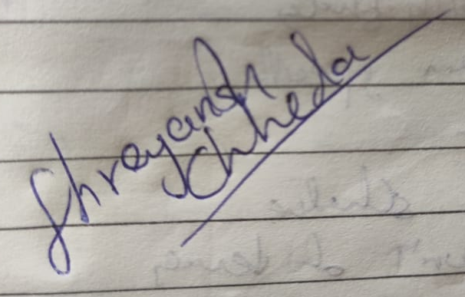
- List of students along with offered elective course will be displayed onwww.vjti.ac.inon or before 1stAugust2020

Date:- Signature of the Student

